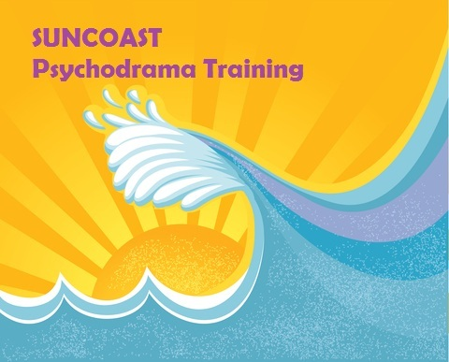
To register:
Mail registration form and check to: Julie Wells, LCSW
2641 Harbor Circle, Clearwater, FL 33759
For further information, please call 727-688-5800 or email journeywellness@aol.com

REGISTRATION FORM FOR “SUNCOAST PSYCHODRAMA TRAININGS”
Name: ______________________________________________________________________
Address: _____________________________________________________________________

Phone ( ) . Email________________________________

Please sign me up for the following trainings:__________________________________

______________________________________________________________________

_____________________________________________________________________________________

_____________________________________________________________________________________
Total Enclosed: $ __________________________________

